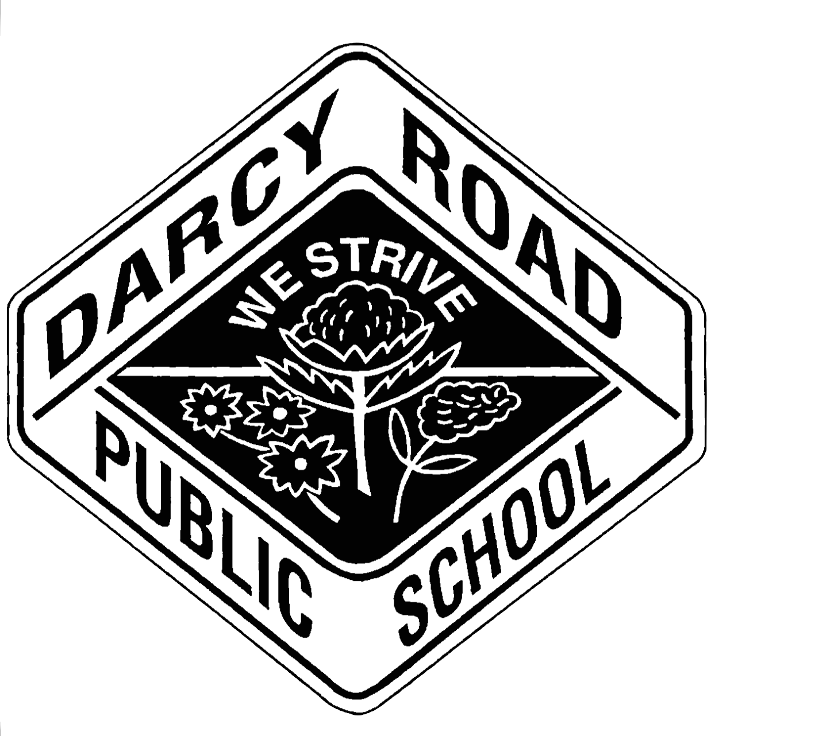

DARCY ROAD PUBLIC SCHOOL

WE STRIVE
BMX Bikes at Darcy Road

11 February 2020

Dear Parent, Caregiver

Our Student Wellbeing Support Officer, Miss Lisa Hawkins will be organising for the continued use of thirteen BMX bicycles with helmets that were donated in 2018. These attractive bicycles, fully checked and approved in accordance with safety standards, will be a useful resource to support student wellbeing in the school

The bicycles are suitable for use on the school bike track by students in Years 3 to 6. Some students will use the bikes during supervised sport on Fridays. Miss Lisa would like to run some ‘learn to ride safely’ sessions for students who are not confident riders.

Other opportunities arise for use at lunchtimes through our ‘Caught You Being Good’ program. Each teacher in Years 3 to 6 may award a yellow ‘Bike Card’ to two students each week, allowing them to ride on the bike track during lunchtime.

Only students who have returned a completed ‘BMX Bike Permission Slip’ will be allowed to use the bicycles. If you would like your child to avail of any of our bike-riding opportunities, please complete the permission slip attached and return to the school “Notes Box’ at the front office.

If you have any questions or comments about the BMX bicycles and their use, please contact Mr McAnally at the school.

Glen McAnally
Relieving Deputy Principal

----------------------------------------------------------- cut here ---------------------------------------------------------

BMX Bikes Parent Permission Slip

I give permission for my child _________________________________ of class ______________
to ride a school BMX bike on the school’s bike track during sports sessions, fitness programs and approved lunchtimes. I understand that helmets are provided and that my child will be reminded or safety rules and routines before using the bicycles.
Signed: ________________________________________ Date: ______________________

